**Plans for today:**

I really liked how well everyone was collaborating on Monday. Today, we will be doing more of that collaboration through the new project assignments. The Saturday section doesn’t have an assignment, and everyone in that class already finished up their lab assignment on Monday, so I will have them work on some practice problems that I’ve made for their upcoming test on Saturday. I will have another practice test prepared for students from the weekday section as well, just in case they would prefer to work on a practice test as well.

**What happened**:

In the beginning, I showed each of the problems on the projector for both sections. Not everyone brought their laptop to class, so I resorted to keeping one of the problems up on the projector. I offered to show more than one problem up on the screen by splitting the screen, but everyone seemed to be working just fine.

I also told students to take a look at the new projects assigned to them this week, just in case they were already done with the homework already. A couple of students decided to work on the project from their section.

At times during class today, I found myself spending too much time with one student, just because the problems are lengthy and require that extra time to explain the full picture. To compensate, I tried told students who were working on the same problem to work in groups together, so that I wouldn’t have to spend so much time on each student. I resorted to the board to explain a problem that many students were working on. Other groups from both sections working on separate problems, also payed attention to what I was explaining on the board, just because of the difficulty of the problem.

On the board, I intentionally showed the long way of solving the problem, to get them to work on concepts that they had been struggling with the week before. After conceptually going through the problem, I encouraged students to work on the problem on their own at home, and that I would be sending them a shell for the problem to help them get started.

After the end of class, I excused students who needed to leave; however, I asked students to stay for another 10 minutes to go over a much simpler way of solving the problem. After going over it on the board, I encouraged students to try to solve the problem using the new way that I showed as well. I’m writing up the email that contains both shells for both methods.

At the very end of class, I made sure to mention the idea of midterm progress meetups. I explained what it was and how I could cancel my office hours to give students the chance to meet up with me for 10 minutes to see how everything was going for them thus far.

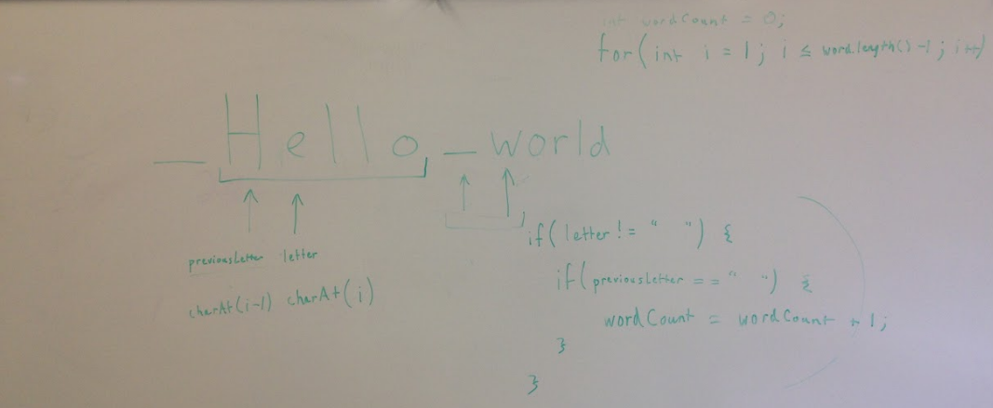

Board work done after everyone was done with their tests. First, I told students in each section to break up into groups to discuss their solutions as I went over the other class’s problem on the board. This allowed from everyone to be working as I covered one problem on the board at a time.

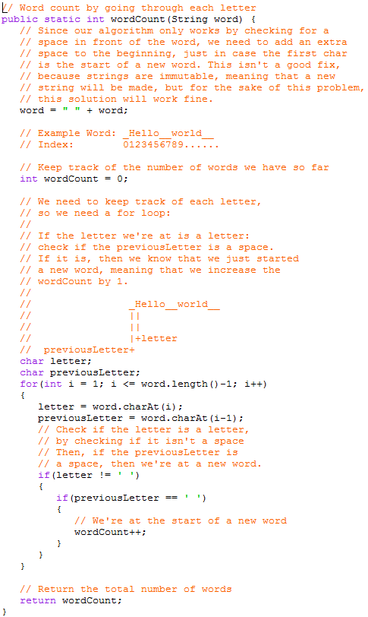

The code that I will be sending out by email. I will be removing most of the code inside the method, but will be leaving in the comments to guide students how to get to the solution themselves.